# Sample Questionnaire

**Introduction:**

Our names are Hannah, Olivia, Raymond, and Tomás, and we are all students from Worcester Polytechnic Institute in Μassachusetts, USA working under Dr. Mavridis at Perrotis College. We are asking you to participate in a survey that has the ultimate goal of assessing the feasibility and value of integrating vertical gardens into the city center of Thessaloniki along Egnatia street, from Democracy square (also known as Vardaris Square) up to and including the University of Macedonia. We believe that through direct citizen engagement in this project, we can propose a plan that will benefit the public. This survey is completely anonymous, but it does include a few questions relating to demographics. This survey is voluntary and you may withdraw at any time. If the data is published, individual responses will be kept anonymous. We ask that you answer honestly, and we thank you for taking the time to participate in our survey.

**What are vertical gardens?**

Vertical gardens are structures that can be placed up walls of buildings that hold plants. They can consist of vines growing up walls, support structures holding larger plants, or hanging vegetation fall over the side of balconies. Some example pictures can be seen below.

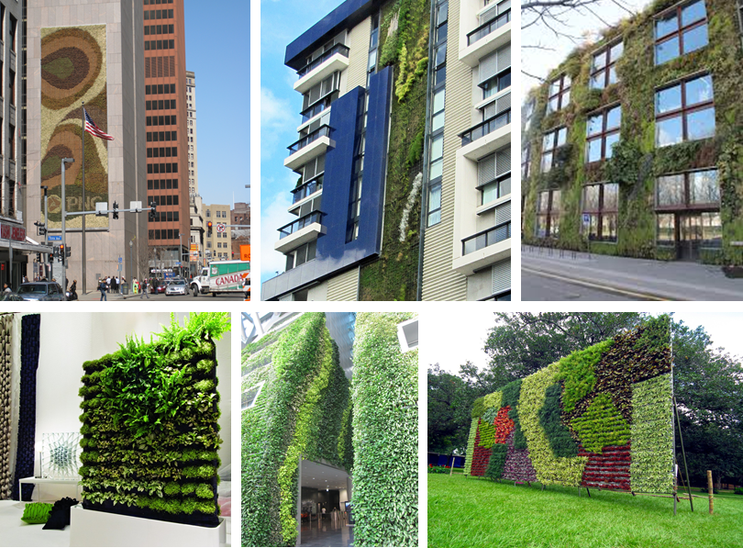

**These questions were given with response options from 1 to 5, 1 corresponding to strongly disagree and 5 corresponding to strongly agree:**

* I think the area around me right now is an attractive area of the city.
* I see a benefit to there being more green spaces on Egnatia Street
* I see a benefit to there being vertical gardens on Egnatia Street
* I think people would vandalize a new public garden on Egnatia Street
* I would be more inclined to go to an establishment with gardens than one without
* I would be more inclined to go to a location with green spaces than without
* Do you believe vertical gardens will contribute to the socioeconomic status of the region

**These questions were given with response options from 0 to 10, 0 being a poor rating and 10 being a good rating**

* How would you rate the amount of greenery on the Egnatia Corridor
* How well do you think that the Egnatia Corridor provides adequate shading?

**These questions were given with the map below:**

* What numbered region of the Egnatia Corridor do you most enjoy walking through?
* What numbered region of the Egnatia Corridor do you least enjoy walking through?

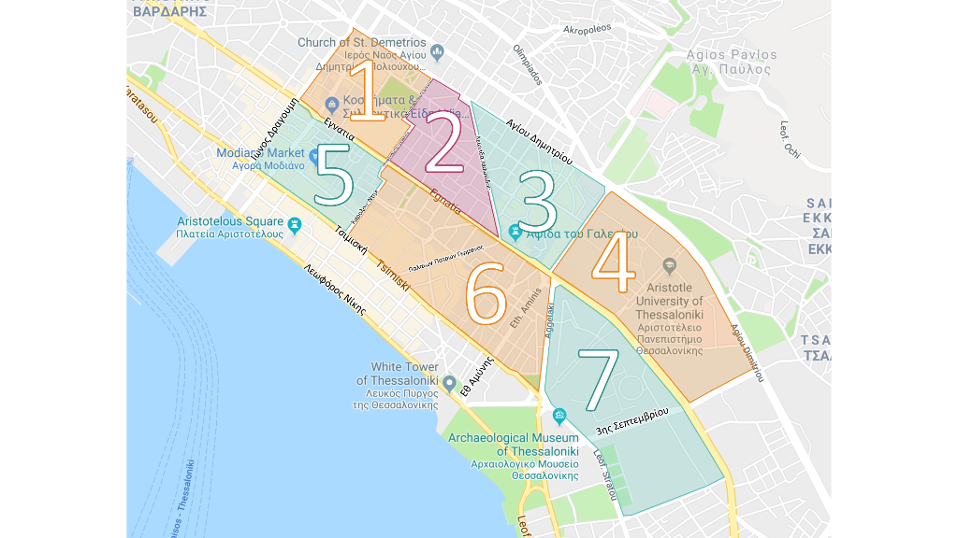

**For the following pictures this question was asked:** Select the option below that represents your preference between the two images. Options were “Strongly Prefer 1,” “Prefer 1,” “Neutral,” “Prefer 2” and “Strongly Prefer 2.”

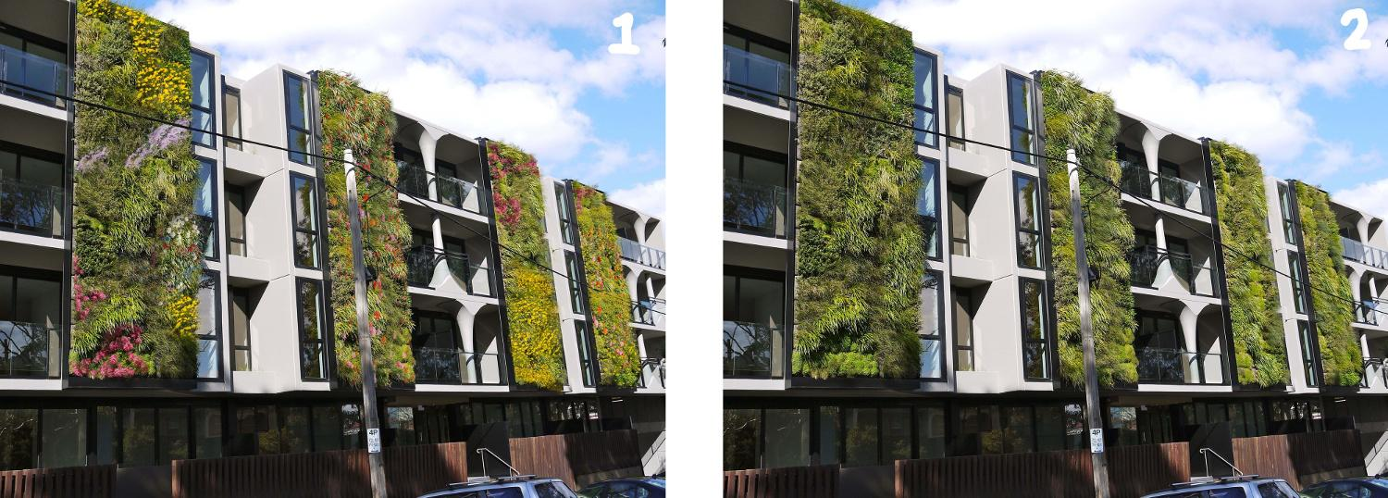

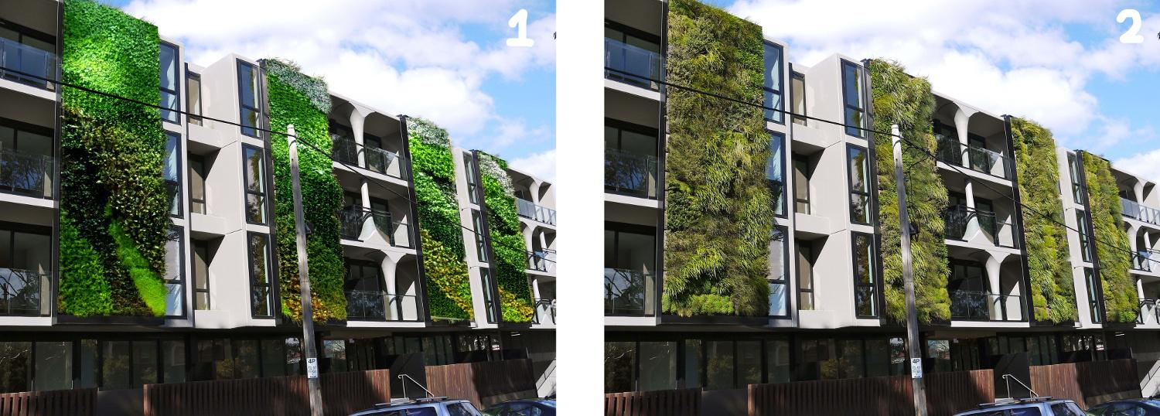

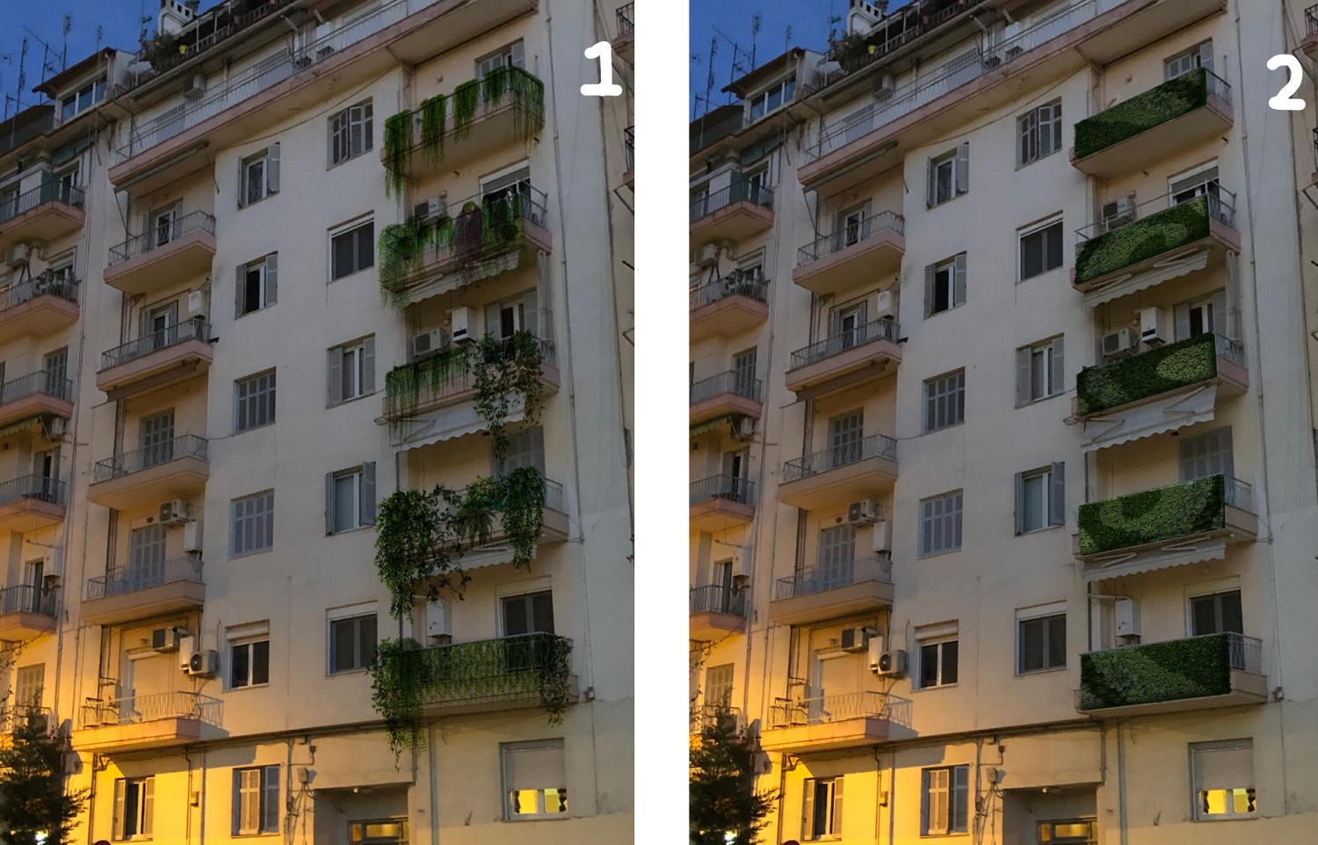

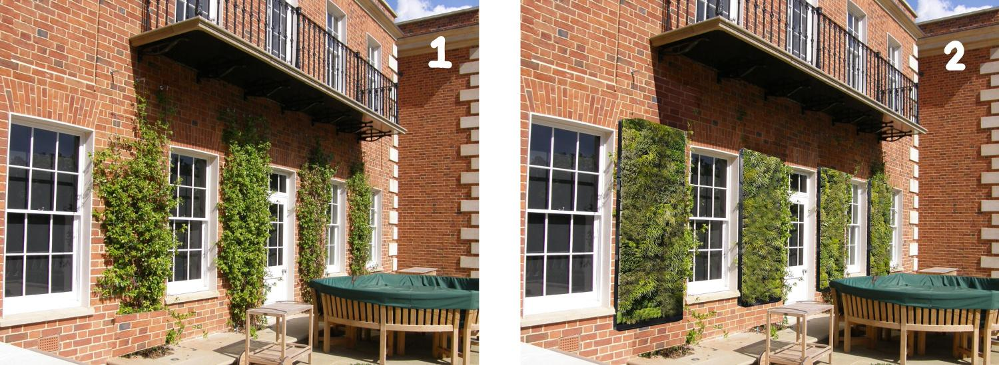

**These questions were given with the map shown below:**

* Based on the map below, what numbered region is your home located in? If you prefer not to answer, you can skip this question. (If the person did not live in the region shown, they could skip this question)
* (If the person works in the region) Based on the map below, what numbered region is your work located in? If you prefer not to answer, you can skip this question. (If the person did not work in the region shown, they could skip this question)

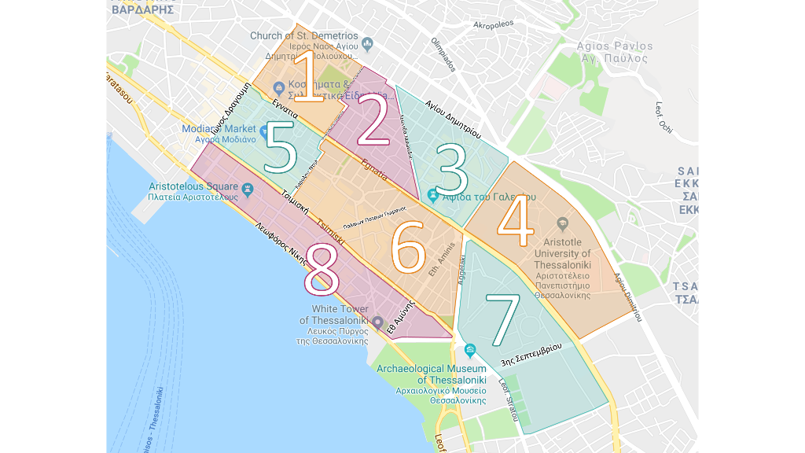

**Demographic Questions, these were all skippable in both versions of the survey:**

* What is your age? (Response Options: “18-30”, “31-45”, “46-60”, “60+”)
* What is your gender? (Response Options: “Male,” “Female,” “Prefer not to answer”)
* If you work along the Egnatia Corridor, how long have you worked in the area? (Response Options: “0-3 years,” “4-8 years,” “9-15 years,” “15+ years”)
* If you live along the Egnatia Corridor, how long have you lived in the area? (Response Options: “0-3 years,” “4-8 years,” “9-15 years,” “15+ years”)
* Do you consider yourself disabled or not? (Response Options: “Yes,” “No,” “Prefer not to answer”)